***Documentation Design***

***Project Title***

***EYEONIC***

***Supervisor***

***Muhammad Hamza***

***Group Details***

|  |  |  |
| --- | --- | --- |
| *Batch* | *2309F3* | |
| *Group* | *B* | |
| Serial No. | Enrollment Number | Student Name |
| *1.* | Student1509532 | MUHAMMAD HUBAB KHAN |
| *2.* | Student1500536 | MUHAMMAD ARSALAN KHAN |
| *3.* | Student1511565 | FATIMA SARFRAZ |

**Acknowledgement**

Before anything, I would like to thanks my beloved teacher who helped us a lot in reviewing this project within the limited time frame.

Secondly, we would also like to thank the E-Project team at Aptech Head Office, who gave us the golden opportunity to do this project of EYEONIC.

Thirdly, we also thank the E-Project team, some of the benefits are as under: Re-enforcement of skills happens in the experiential learning process. ∙ A mentor, ensuring that we do not get drifted, constantly guides us. ∙ It gives us a lot of confidence to face an interview as we have worked on a project. We can explain virtually everything on the subject we have worked on.

**Problem Definition**

The Eyeonic project endeavors to bridge this gap by reimagining eyewear as a harmonious fusion of advanced optical technology, personalized style, and ergonomic design. By addressing the inherent challenges of the current eyewear landscape, Eyeonic aims to deliver a transformative experience that empowers users with eyewear that not only meets but anticipates their evolving needs, setting new standards for innovation and style in the eyewear industry***.***

**Customer Requirement Specification**

The Web site is to be created based on the following requirements.

1) Home Page should contain logo of the site with proper sections and details of

Frames and Lenses with suitable images.

2) The site should display a menu which will contain the options for brief

introduction about the various frames and lenses available, location of the

shop and any other information if required.

3) The information should be categorized according to the brand names of the

products like if a User wants to see only “Ray-Ban” products or any other

companies’ products then he/she can click on a Link/button/menu etc and can

see only that Brand products.

4) Another category option for “Contact Lenses”, “SunGlasses” etc. should be

created and accordingly the products should be listed.

5) When a user selects any particular brand, a list of products for that brand will

be displayed

6) A brief summary of features of individual products should be displayed on the

Web Page along with the product but detailed Features should be stored in

Individual Word documents which can be downloaded or viewed by the User

who wishes to see the same.

7) The user should also be able to compare the various products of different as

well as similar brands.

8) There should be a “Contact Us” page which will have the Address of the

Company which is as follows and the mail address which when clicked will

invoke the local mail client from where they can send an email.

**Scope**

Eyeonic website is all about changing how you experience eyewear. We offer a carefully curated selection of stylish and comfortable eyewear. Our goal is to provide a user-friendly platform for exploring and customizing eyecare solutions.

**Aggregated Sitemap**

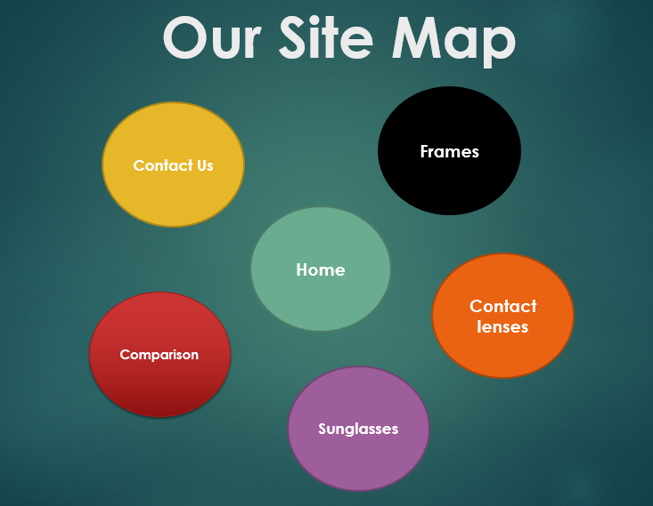

**HOME : (index.html)**

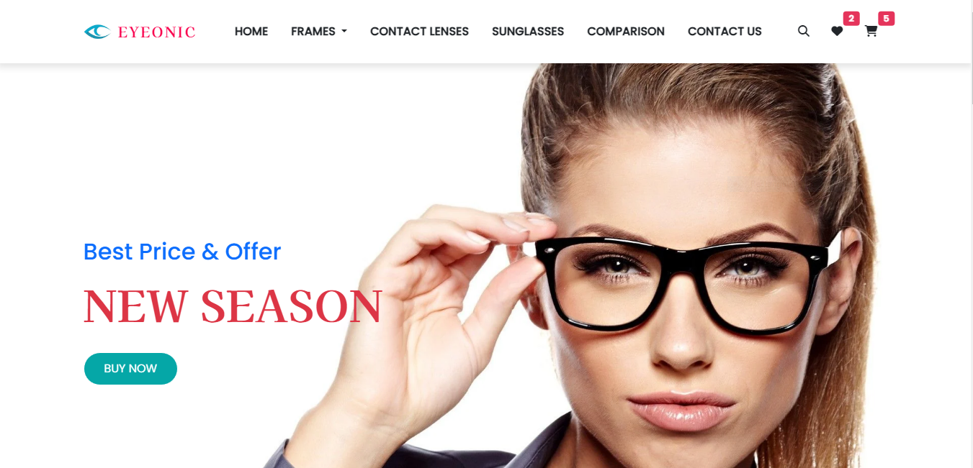

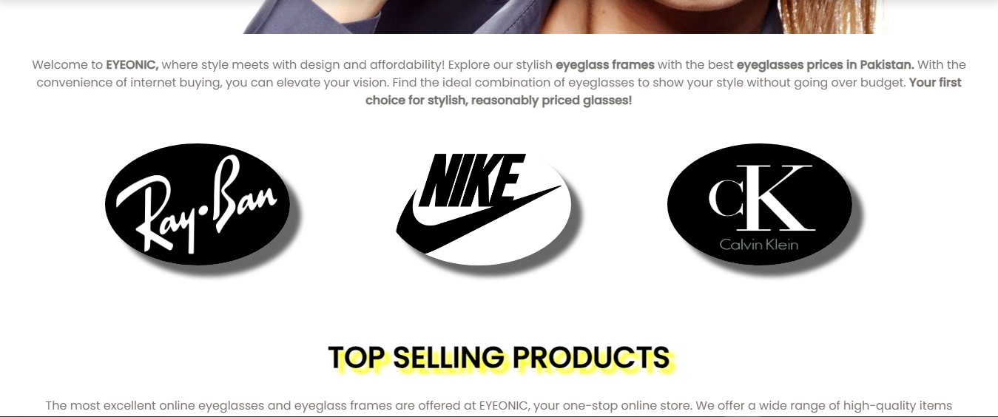

**HOME : (index.html)**

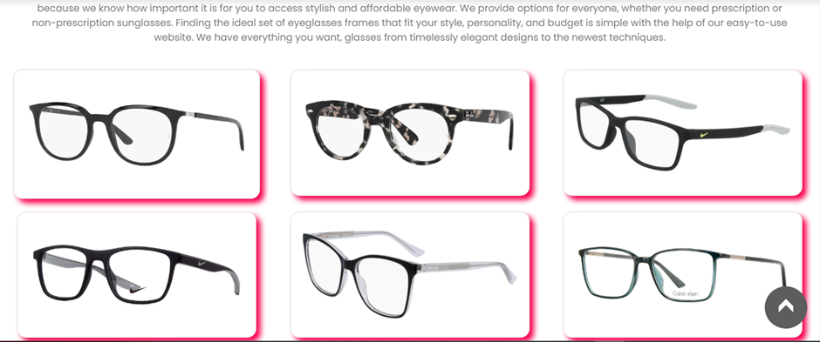

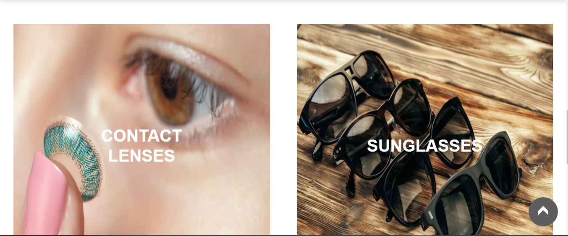

**HOME : (index.html)**

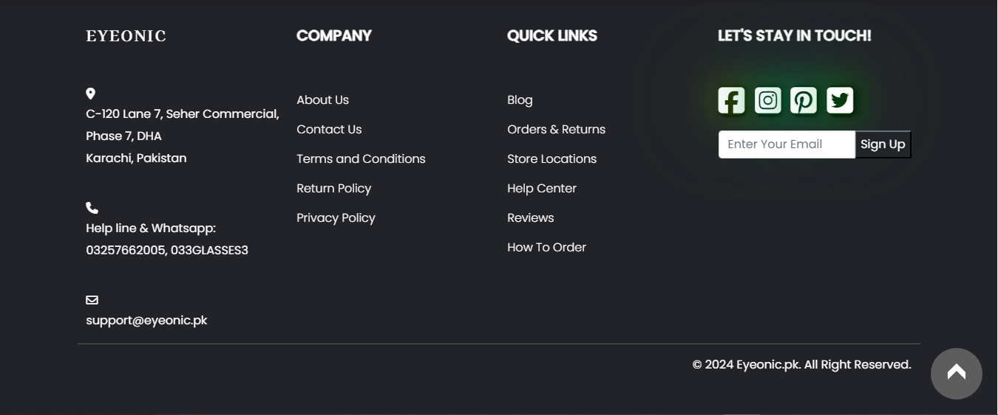

**FRAMES : Ray-Ban (ray-ban.html)**

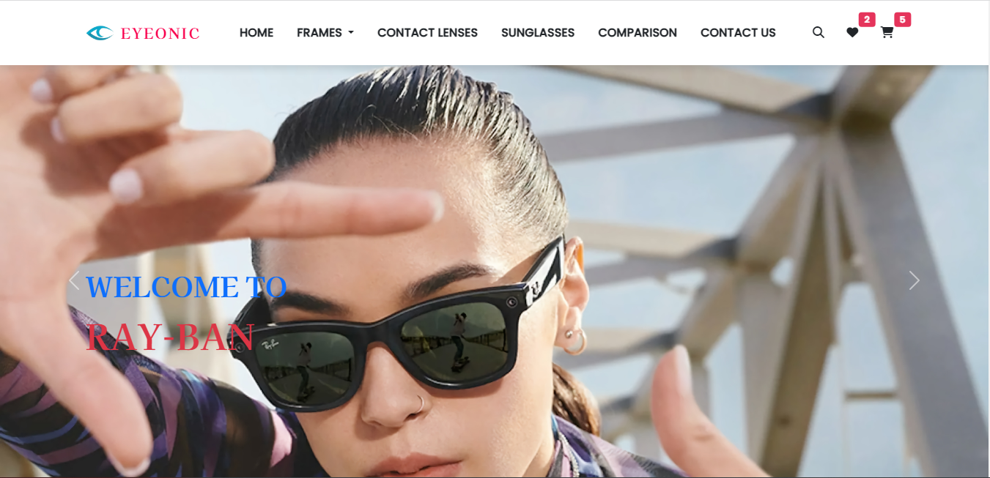

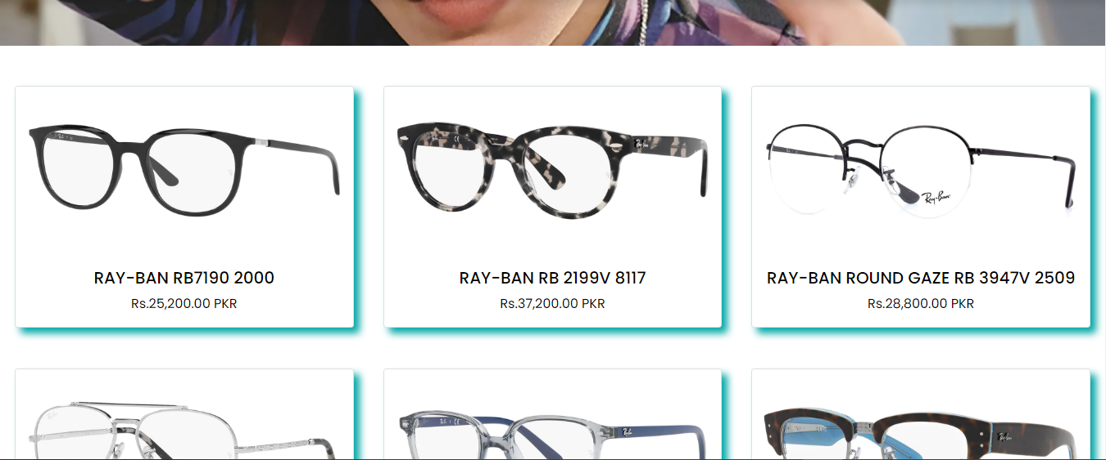

**FRAMES : Nike (nike.html)**

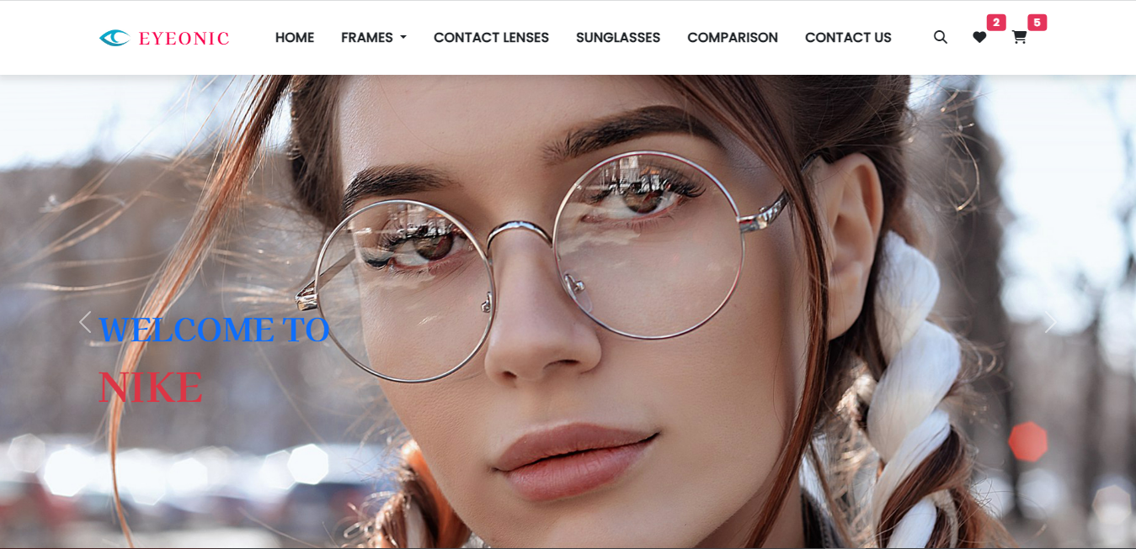

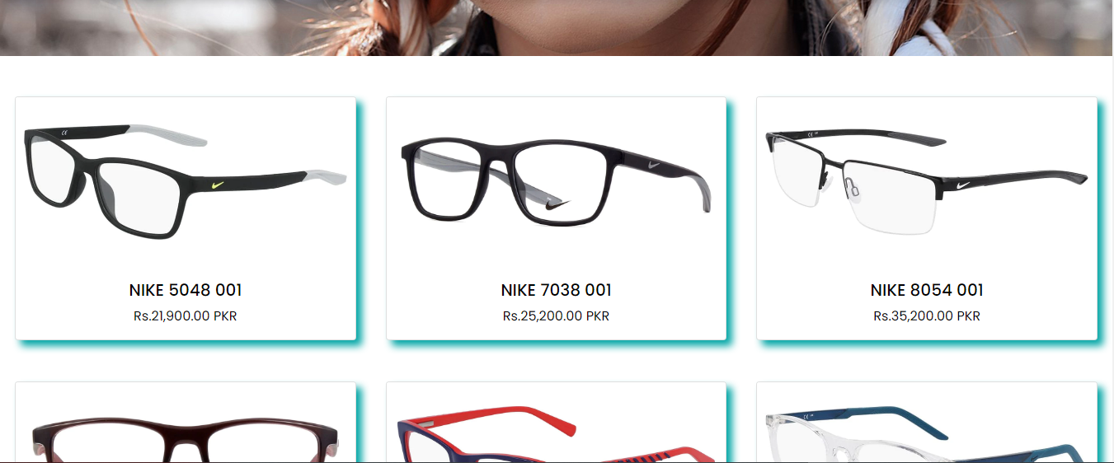

**FRAMES : Nike (nike.html)**

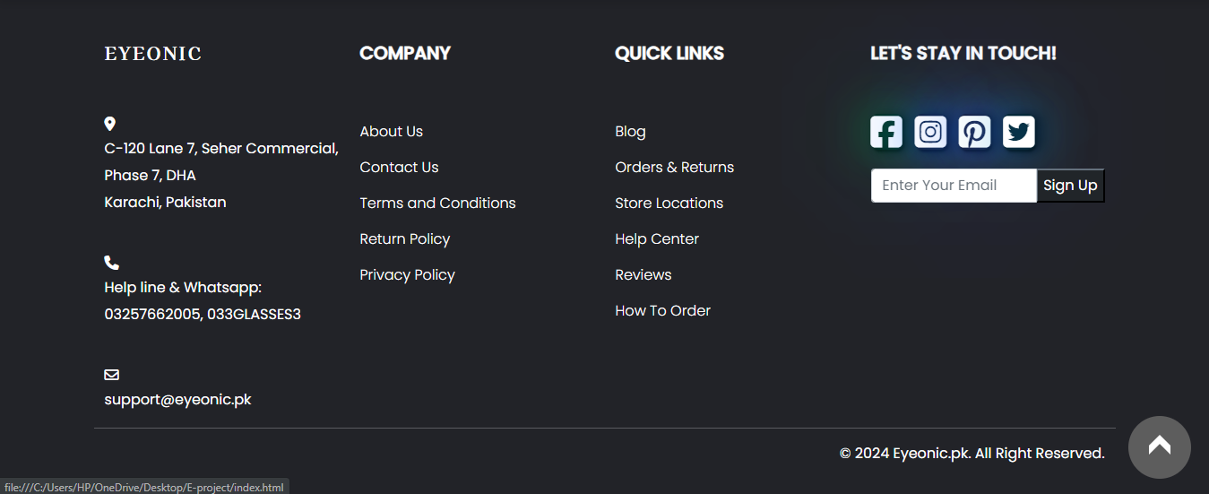

**FRAMES : Calvin Klein (calvin.html)**

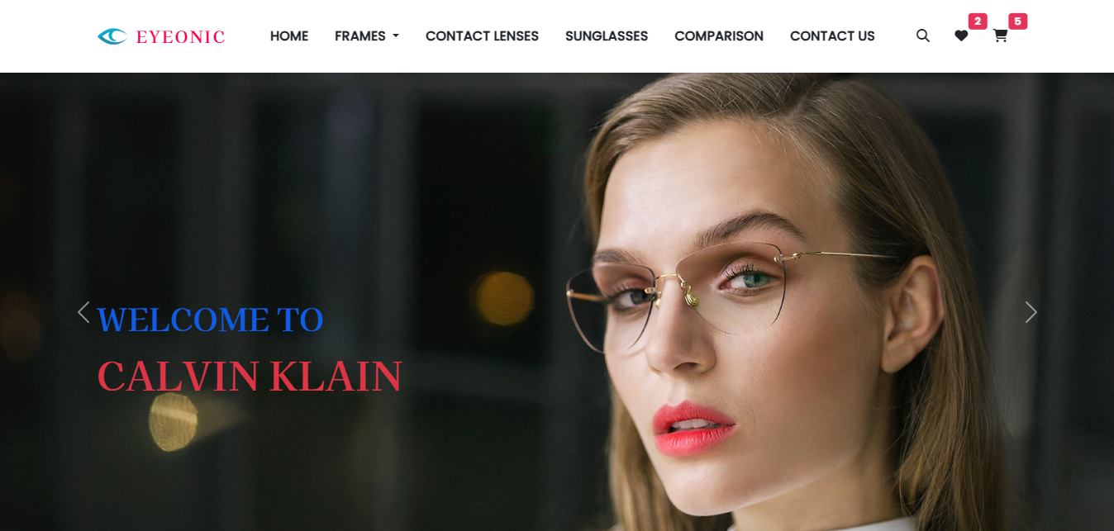

**FRAMES : SUNGLASSES (sunglasses.html)**

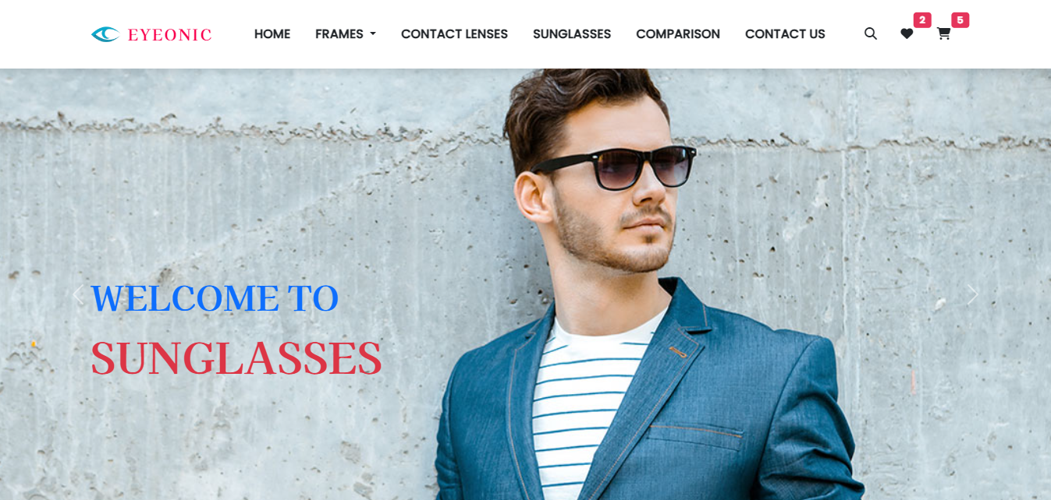

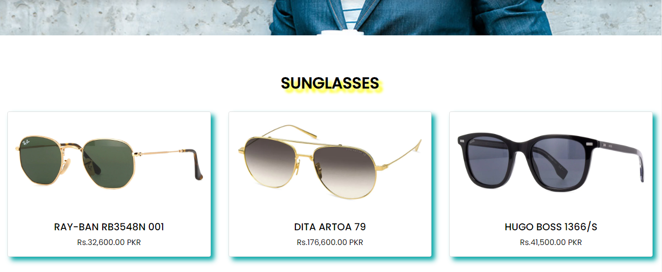

**COMPARISON (compare.html)**

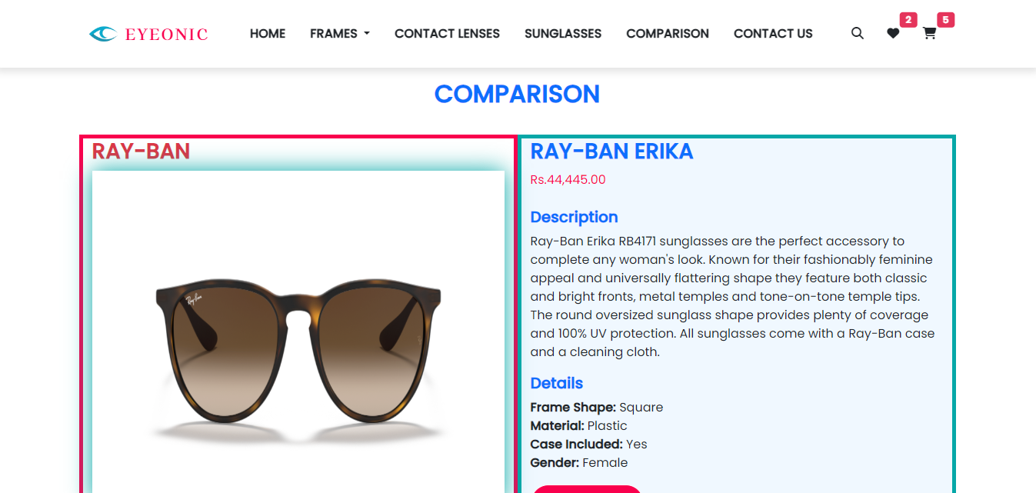

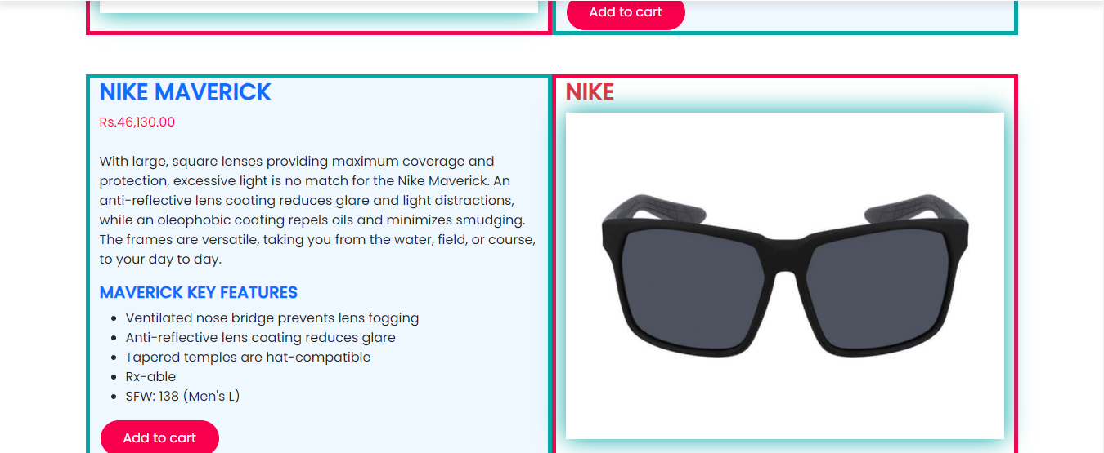

**COMPARISON (compare.html)**

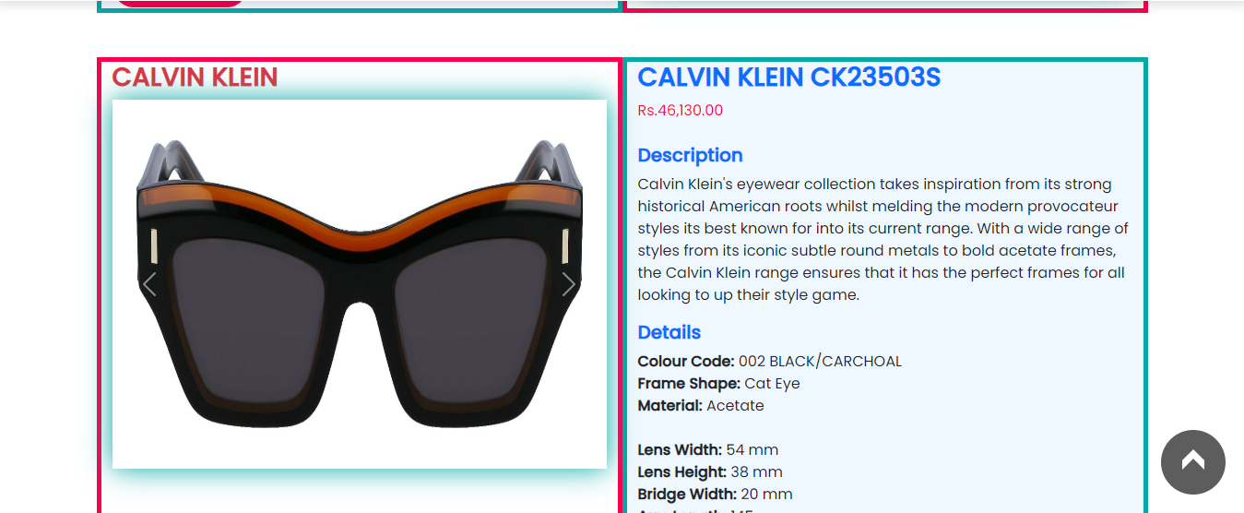

**CONTACT US (contact.html)**

